Big Mountain Summary Report

My client Big Mountain Resort is looking to either increase ticket cost using facilities as its main resource of evidence or decrease its cost by shutting down irrelevant or insignificant facilities. With the installation of a new lift chair costing $1.5 million this season, they’re looking to optimize its ticket price through the given data.

After processing the data, we have evidence that supports increasing ticket cost based on the facilities given. We also have a couple scenarios that can support increased ticket cost while doing the opposite of said scenarios can decrease ticket revenue.

In the first scenario, we looked to remove runs to see how it can affect ticket price and revenue. In alignment with the chart above, we can see it negatively impacts both cost and revenue. This provides a secondary scenario option which includes increasing the amount of runs and may increase ticket price which in turn increases revenue. This next scenario supports this idea.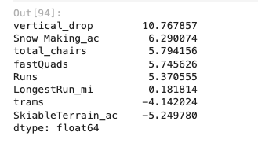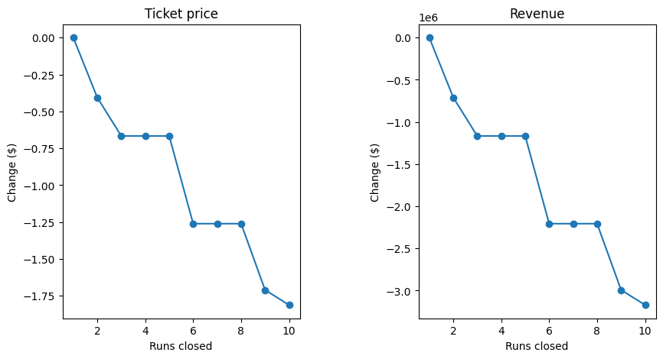

In the second scenario, we looked to increase the amount of runs by 1, the vertical drop by 150, and the number of lift chairs by 1. The resulting prediction with our model included an increase in ticket price by nearly $2, thus increasing revenue by $3.47 million seasonally. If we look at the chart on the right, the positive numbers align with ticket increase, which in turn also supports the given scenario.

In closing, Big Mountain is in top of its league when it comes to facilities. Vertical drop, area covered by snow, total chairs, runs, and fast quads all are positive influences toward a higher ticket price and Big Mountain does well in all of them as shown in some of these last charts.

